Planned Programme Dates:
Wednesday 17th January 6pm to 7pm in Church - Introduction to the programme, dates, meet the Catechists, introduction to I Belong book.
Wednesday 24th January 6pm to 7pm Chapter 1 -The Creation https://www.youtube.com/watch?v=teu7BCZTgDs
The Baptism of Jesus Baptism video https://www.youtube.com/watch?v=_VMNO2MAmwA
Chapter 2 - Penitential Rite, Prodigal Son Video (74) LEGO - The Prodigal Son - YouTube
Wednesday 31st January 6pm to 7pm Zoom Chapter 5 - Glory to God
Moses and the Burning Bush https://www.youtube.com/watch?v=QdxJLTWkv5A&t=21s
Gloria & link to Christmas story & angels greeting the shepherds with good news. Hymn the Clapping Gloria https://www.youtube.com/watch?v=U0SrN4B-HTU
Chapter 6 - Word of the Lord Samuel’s Call. Video https://www.youtube.com/watch?v=Ewa8OwQtVwU
Mass readings OT, Responsorial Psalm, NT, Gospel & responses.
Wednesday 7th February 6pm to 7pm Chapter 7- Bread to offer – preparation for the Eucharist Feeding of the 5000. Video https://www.youtube.com/watch?v=S6rj9cAJrWE Offertory gifts and preparation. Making bread at home…love to see photos of the bread!
Chapter 8 - Fruit of the wine – wedding feast at Cana. Video https://www.youtube.com/watch?v=S6rj9cAJrWE Celebrations. Remembering Past & Present, & planning for the Communion Day
Thursday 12th February – Half Term Week
14th February - Ash Wednesday
Wednesday 21st and 28th February - Practical Sessions in Church The tour and discuss entry to the Church, various rituals, the Sign of the Cross, preparation for the Mass/Eucharist.
Wednesday 6th March 6pm to 7pm
Chapter 9 - The Last Supper & preparation for the Eucharist, Passover video https://www.youtube.com/watch?v=1IwMt-KLkSE Lamb of God & Sign of Peace
Chapter 10 - Body of Christ – Story of Risen Lord & story of Mary in the garden video https://www.youtube.com/watch?v=UtSfON2qHEc
Eucharist preparation, Consecration & receiving the Body of Christ at Communion
Wednesday 13th March 6pm to 7pm Zoom Chapter 11- Go in peace to love and serve the Lord To love & to serve looking at different ways to serve in community – offering to help and to be a good friend & neighbour. Letter of thanks to Parents & God parents. Prayers P129
Wednesday 20th March Reconciliation Preparation 6pm to 7pm Chapter 3 - Rescue story of Daniel video https://www.youtube.com/watch?v=bEM_X25DWPk
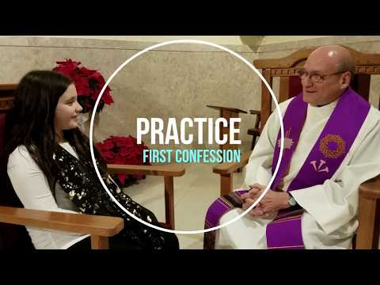
Chapter 4- Zacchaeus video https://www.youtube.com/watch?v=5Bjt bJFz2ug
Act of Sorrow or Contrition O my God, I am sorry for what I have done wrong,
I know you love me, and I want to love you too.
With your help I will try not to sin again. Amen
First Confession Guide
Penitential Service for Children – Order of Service to upload.
Easter Holidays 28th March to 14th April 29th March Good Friday – Children Stations of the Cross 31st March Easter Sunday
Wednesday 17th and 24th April 6pm to 7pm Practical Sessions in Church to practise Reconciliation.
Wednesday 1st May (St Joseph the Worker) 6pm – The Sacrament of First Reconciliation with children in the church
Check books have been completed.
Thursday 9th May - Ascension of the Lord

First Holy Communion Masses
Saturday 11th May - Rehearsal on Wednesday 8th May
Saturday 18th May- Rehearsal on Wednesday 15th May
