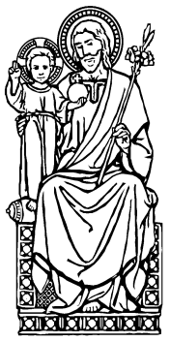
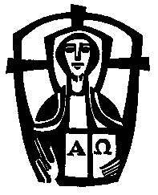
St Joseph’s Church
Wealdstone and Harrow Weald
Served by the Society of the Divine Saviour – The Salvatorians
Parish Priest: Father Thomas Malal SDS
Assistant Priests: Father Frank Waters SDS; Father Mario Lainez SDS
191 High Road, Harrow Weald, HA3 5EE
Tel: 020 8427 1955, email: office@catholicwealdstone.org
Parish Office: Mon & Tues 9am-2pm; Wed-Fri 9am-4pm
www.catholicwealdstone.org
Also in the Parish: Sisters of Our Lady of the Missions
108 Spencer Road, Harrow Weald, HA3 7AR
Salvatorian Trustees Registered Charity No 231410

REGISTRATION FORM FOR FIRST HOLY COMMUNION 2023 - 2024
Please complete in BLOCK CAPITALS

FULL NAME ……………………………………………………………………...

D.O.B. ………………………….

HOME ADDRESS …………………………………………………………………………….………………….

…………………………………………………………………………………………………………………….
PARENTS/ GUARDIANS

…………………………………………………………………………….……………………………………….

TELEPHONE ………………………………………………... EMAIL…………………………………………

SCHOOL ……………………………………………………………………. YEAR GROUP …………………

CHURCH OF BAPTISM …………………………………………………….

CERTIFICATE ……….………………………….

ADDITIONAL INFORMATION (allergies, medical info, learning difficulties, etc)
……………………………………………………………………………………………………………...………

………………………………………………………………………………………………………………...…

RELATIVES ALSO RECEIVING FIRST HOLY COMMUNION/CONFIRMATION - YES / NO

NAMES, IF YES ………………………………………………………………………………………………...

£30 COURSE FEE PAID - YES / NO

